**EKS CLI Installation**

Here we are using AWS CloudShell Terminal.

$ sudo -i : Switch to root user

# aws -- version : Check AWS CLI

# aws configure : Here skip all step as blank

**1.** **Download kubectl**:

curl -LO [https://storage.googleapis.com/kubernetesrelease/release/${KUBECTL_VERSION}/bin/linux/amd64/kubectl](https://storage.googleapis.com/kubernetesrelease/release/$%7bKUBECTL_VERSION%7d/bin/linux/amd64/kubectl)



**2. Make it executable:**

# chmod +x ./kubectl

- Changes the permissions of the downloaded file to make it executable.

**3. Move it to a system path:**

# sudo mv ./kubectl /usr/local/bin/kubectl

- Moves the kubectl binary to /usr/local/bin, making it accessible from anywhere in the terminal.

**4. Check kubectl version:**

# kubectl version --client



Note- Ignore error.

**5. Installing eksctl**

**Download and extract eksctl**:

curl --silent --location "https://github.com/weaveworks/eksctl/releases/latest/download/eksctl_Linux_amd64.tar.gz" | tar xz -C /tmp

- Downloads the latest version of eksctl and extracts it to the /tmp directory.

**6. Move eksctl to a system path:**

# sudo mv /tmp/eksctl /usr/local/bin

- Moves the eksctl binary to /usr/local/bin for easier access.

**7. Make eksctl executable:** - Sets executable permissions for the eksctl binary.

# sudo chmod +x /usr/local/bin/eksctl

**8. Check eksctl version:**

# eksctl version



**9. Creating and Managing an EKS Cluster:**

**Create an EKS cluster:**

eksctl create cluster --name my-new-cluster --region ap-south-1 --nodegroup-name my-nodes --node-type t3.medium --nodes 1 --nodes-min 1 --nodes-max 1 –managed

-- Creates a new EKS cluster named my-new-cluster in the specified region with a managed node group named my-nodes. It specifies instance type (t3.medium) and the desired, minimum, and maximum number of nodes (all set to 1).

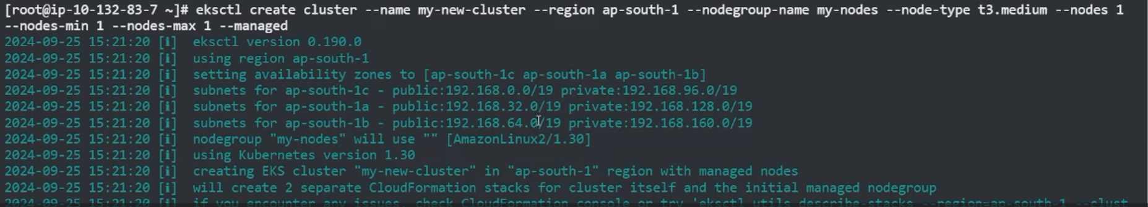

**10. Check EKS from console**

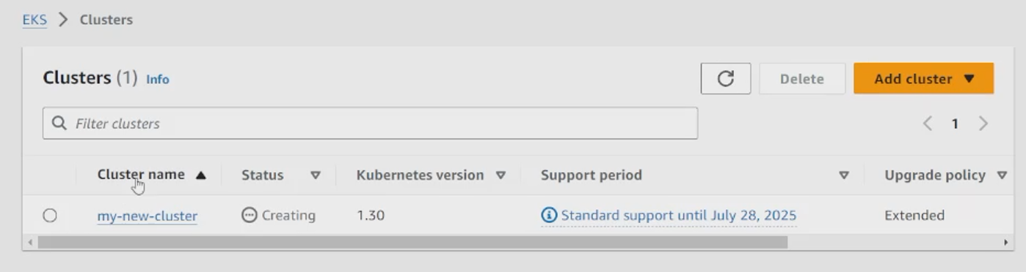

It takes some time to create Cluster & also node.